Event Listeners

Design an editor page that would restrict the functions such as cut, copy, and paste using javascript code.  
  
Sample Screenshot  :  
  
On entering the data in the textarea,  
  
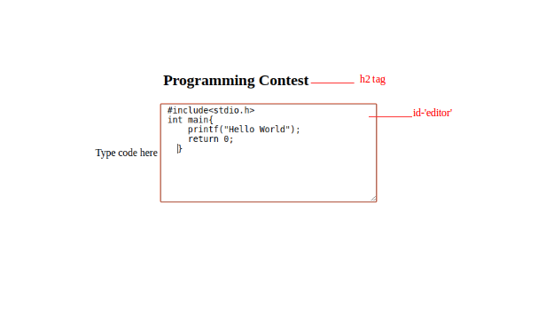  
  
Constraints :  
  
When we try to select and cut/copy/paste the data, this alert box should pop up.  
  
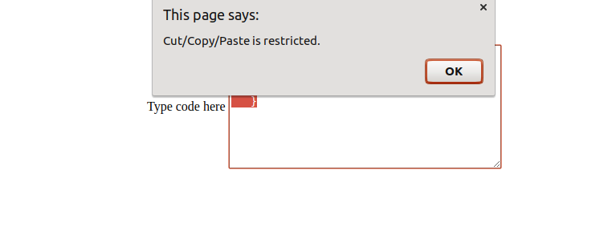  
  
Additional Constraints:  
  
The filename should be index.html  
**Use oncut attribute for cut, oncopy attribute for copy and onpaste attribute for paste.**  
Refer to the screenshots for the id to be used.  
Use the event listeners to restrict cut,copy and paste in the webpage.

|  |  |
| --- | --- |
| Function name | Description |
| warning() | This method is used to display the alert 'Cut/Copy/Paste is restricted.' |